Practical No. 4
Aim : 2) WAP to check the largest of three numbers.

Name : Danish Altaf Solkar | Class : CO - B
Enrolment no. : 24111590805 | Batch : 2

Code :-
#Read three numbers from the user
a=int(input("Enter first number : "))
b=int(input("Enter second number : "))
c=int(input("Enter third number : "))
#Check the largest number
if a>=b and a>=c:
print("Largest number is ",a)
elif b>=a and b>=c:
print("Largest number is ",b)
else:
print("Largest number is ",c)

OUTPUT :-
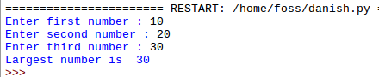

Process related  (30) | Product related  (20) | Total Marks  (50) | Signature

